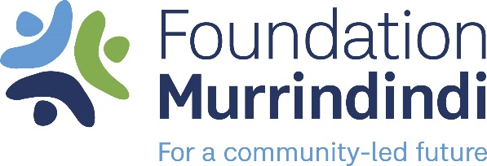

**TRIANGLE PROJECTS GRANTS PROGRAM**

Grant Opens **Sept 1st 2023**. Grant Closes **30th Sept 2023**

**1. Program Overview and Objectives**

The Foundation is seeking to support community organisations to deliver projects or programs that benefit senior residents of the Marysville and Triangle area within the Murrindindi Shire. Whilst the preference is to fund projects for senior residents, the fund does not prohibit funding projects for other sectors and beneficiaries within the Marysville and Triangle communities.

Funding is available for projects that demonstrate impact in one of the Foundations key areas of impact:

* Building Community Capacity
* Community Health and Wellbeing
* Arts & Culture
* Environment & Sustainability
* Youth Success

1. **Program Eligibility Criteria**

Eligible applicants can apply for grants to support the initiation, development and delivery of projects that provide positive impact to Senior residents within the Triangle area of the Shire of Murrindindi. This includes Marysville, Granton, Narbethong, Buxton and Taggerty.

To be eligible to apply for funding through Triangle Projects Grants Program, applications must meet the following criteria:

* Applicant organisations must be a not-for-profit organisation or community group.
* Applicant organisations must be located within the Shire of Murrindindi with the project providing benefits and positive impact to local people within the Triangle area.
* Priority will be given to projects that clearly demonstrated a link to Senior residents. Other community related projects are welcome to apply.

Funding will not be considered for:

* Activities with a religious or political focus
* Commercial activities
* Fundraising activities, competitions, prizes or award events
* Activities that have already commenced or occurred

1. **Assessment Process**

After the application period has closed and we have received your application:

* You will receive an email confirming receipt of your application through SmartyGrants online portal.
* Your application will be assessed against the eligibility and assessment criteria.
* Funding recommendations will be advised by Foundation Murrindindi Grants & Programs Sub Committee.
* Foundation Murrindindi Board will make the final decision on the outcome of all eligible applications.
* All applicants will receive a notification via email with the result of their application by the end of October 2023
* Information about grant decisions will not be given over the phone.
* The list of successful applicants will be published on the Foundation Murrindindi’s website and social media platforms approximately a month after all applicants have been notified of the outcome of their application.

1. **Assessment Criteria**

Grant applications are assessed against the following assessment criteria:

* Alignment to the purpose and objectives of Triangle Projects Grants Program
* Demonstrated community need
* Number of participants that will participate and benefit
* Budget reflects appropriate scope and scale of intended activity.

For more information contact Robyn Hill, Executive Officer

Ph: 0488 007 688

Email [robyn@foundationmurrindindi.org.au](mailto:robyn@foundationmurrindindi.org.au)

Please apply online via our website

<https://foundationmurrindindi.org.au/>